

**Provisioning Template to Create Virtual**

**User Guide**

|  |  |  |
| --- | --- | --- |
| **Version** | **Remarks** | **Date** |
| **1.0** | **Provisioning Template User Guide for Create Virtual Server** | **21/07/2016** |
| **2.0** | **Updated document with installation of the template.** | **14/02/2017** |
|  |  |  |
|  |  |  |

## Installation of the Template and Helper Script

1. Login to AppViewX.
2. On the left navigation menu, select ***Provisioning***; and click ***Template.***
3. On the upper right portion of the screen click on the  Import button.
4. The following screen will appear. 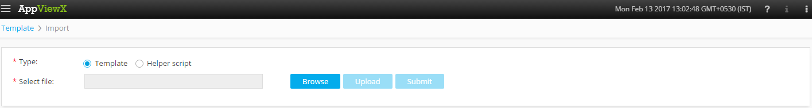
5. Please Select Template/Helper Script.  
   If Template is chosen,
   1. Click on *Browse* and select the Zip File of the template which has to be installed/imported and click open.
   2. Click on upload to import the Zip file and display the templates present in the zip file.
   3. Click on submit to deploy the templates into the AppViewX Environment.

If Helper Script is chosen,

1. Click on *Browse* and select the Zip File of the Helper script which has to be installed/imported and click open.
2. Click on upload to import the Zip file and display the Helper Scripts present in the zip file.
3. Click on submit to deploy the Helper Scripts into the AppViewX Environment.

## Create VIP Template

1. Login to AppViewX.
2. On the left navigation menu, select ***Provisioning***; and click ***Request***
3. On the upper right portion of the screen, click the  ***Create*** button.
4. Select the provisioning template name from the list – ‘**Create_VIP_Template**’

**Note:** *If no template is available, this indicates that the user role does not have permission to the requesting template.*

1. Enter the provisioning request description – ‘*Create Virtual Server on F5/Citrix device*’.
2. Add a default Request scenario name relevant to the template. ***E.g***.: VIP creation on F5/Citrix ADC.
3. Select the ADC vendor from the available list of vendors in the **Vendor** field. ***E.g***.: F5, Citrix,...

If **F5** is selected, then

* 1. Click on ‘***Get Device List***’ button to fetch the available list of devices in the inventory for the selected vendor.
  2. In the **Device** field, list of devices are populated based on the *Vendor* selected. Please select the device on which the VIP is to be created.
  3. Please enter a valid *Application name* in the **App Name** field.
  4. If IPAM integration is required, select **Yes** in the ‘***Integrate with IPAM’*** field and select the required IPAM (Infoblox/Bluecat).  
     If Infoblox is selected,
     1. Please select the Infoblox device by clicking on get infoblox devices button.
     2. Retrieve the list of **subnets** available on the device by clicking on the  button and select the required subnet.
     3. Click on reserve free IP to reserve the IP.

If Bluecat is selected,

* + 1. Please select the Bluecat device by clicking on get Bluecat devices button.
    2. Retrieve the list of **subnets** available on the device by clicking on the  button and select the required subnet.
    3. Click on reserve free IP to reserve the IP.
  1. If IPAM integration is not required, select **No** in the ‘***Integrate with IPAM’*** field.
  2. Enter the *IP* and *Port* in the respective fields and click on ***Get Details.***
  3. Select the *Persistence profile* from the list of available profiles in the **Persistence** field.
  4. Specify if *HTTP Profile* has to be created from the **Create HTTP Profile** field and subsequently selecting the ***Defaults from****.*
  5. Specify if *HTTP Monitor* has to be setup. If yes, the following fields needs to be entered.

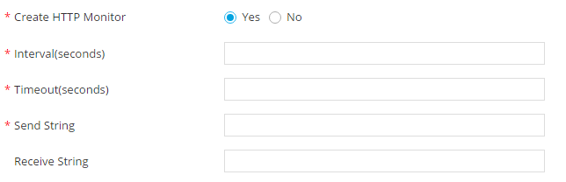

* 1. Existing monitors can be applied to the Virtual Server by selecting any existing monitor from the ***Use Existing Monitor*** dropdown list.
  2. The load balancing algorithm can be selected from the ***Load Balancing Method*** dropdown list.
  3. *Pool Member IP* and *Pool Member Port* can be added and by clicking on the , the specific Pool members can be added to the tabular for associating to the Virtual Server.
  4. Click  Button; ensure that the Scenario is displayed on the right hand pane.
  5. Click on *Submit* to generate work order(s) for the provisioning request.

If **Citrix** is selected, then

1. Click on ‘***Get Device List***’ button to fetch the available list of devices in the inventory for the selected vendor.
2. In the **Device** field, list of devices are populated based on the *Vendor* selected. Please select the device on which the VIP is to be created.
3. Please enter a valid *Application name* in the **App Name** field.
4. If IPAM integration is required, select **Yes** in the ‘***Integrate with IPAM’*** field and select the required IPAM (Infoblox/Bluecat).  
   If Infoblox is selected,
   * 1. Please select the Infoblox device by clicking on get infoblox devices button.
     2. Retrieve the list of **subnets** available on the device by clicking on the  button and select the required subnet.
     3. Click on reserve free IP to reserve the IP.

If Bluecat is selected,

* + 1. Please select the Bluecat device by clicking on get Bluecat devices button.
    2. Retrieve the list of **subnets** available on the device by clicking on the  button and select the required subnet.
    3. Click on reserve free IP to reserve the IP.

1. If IPAM integration is not required, select **No** in the ‘***Integrate with IPAM’*** field.
2. Enter the IP and Port in the respective fields and click on Get Details.
3. Specify if HTTP Monitor has to be setup. If yes, the following fields needs to be entered.



1. Existing monitors can be applied to the Virtual Server by selecting any existing monitor from the **Use Existing Monitor** dropdown list.
   1. The load balancing algorithm can be selected from the ***Load Balancing Method*** dropdown list.
   2. *Server Name, Server IP* and *Service Port* can be added and by clicking on the, the specific Service List can be added to the tabular for associating to the Virtual Server.
   3. Click  Button; ensure that the Scenario is displayed on the right hand pane.
   4. Click on *Submit* to generate work order(s) for the provisioning request.